**Q.1. Write a prolog program to show the use of following operators in prolog.**

|  |  |
| --- | --- |
| **Operator** | **Meaning** |
| **+** | **Addition** |
| **-** | **Subtraction** |
| **\*** | **Multiplication** |
| **/** | **Division** |
| **\*\*** | **Power** |
| **//** | **Integer Division** |
| **mod** | **Modulus** |

**Objectives:**

The objective of this Prolog program is to demonstrate the use of basic arithmetic operators within the Prolog environment. Specifically, the program aims to provide clear examples of addition, subtraction, multiplication, division, power, integer division, and modulus operations. Through a series of queries, users will learn how to apply these operators to perform arithmetic calculations in Prolog. Additionally, the program seeks to highlight the differences between floating-point division and integer division, as well as to explain the practical use of the modulus operator. Ultimately, this program serves as a comprehensive guide for understanding and utilizing arithmetic operations in Prolog.

**Code:**

cal:-

A is 100+10,write(A),nl,

B is 100-10,write(B),nl,

C is 100*10,write(C),nl,

D is 100/10,write(D),nl,

X is 100//10,write(X),nl,

Y is 100 mod 10,write(Y).

**Output:**

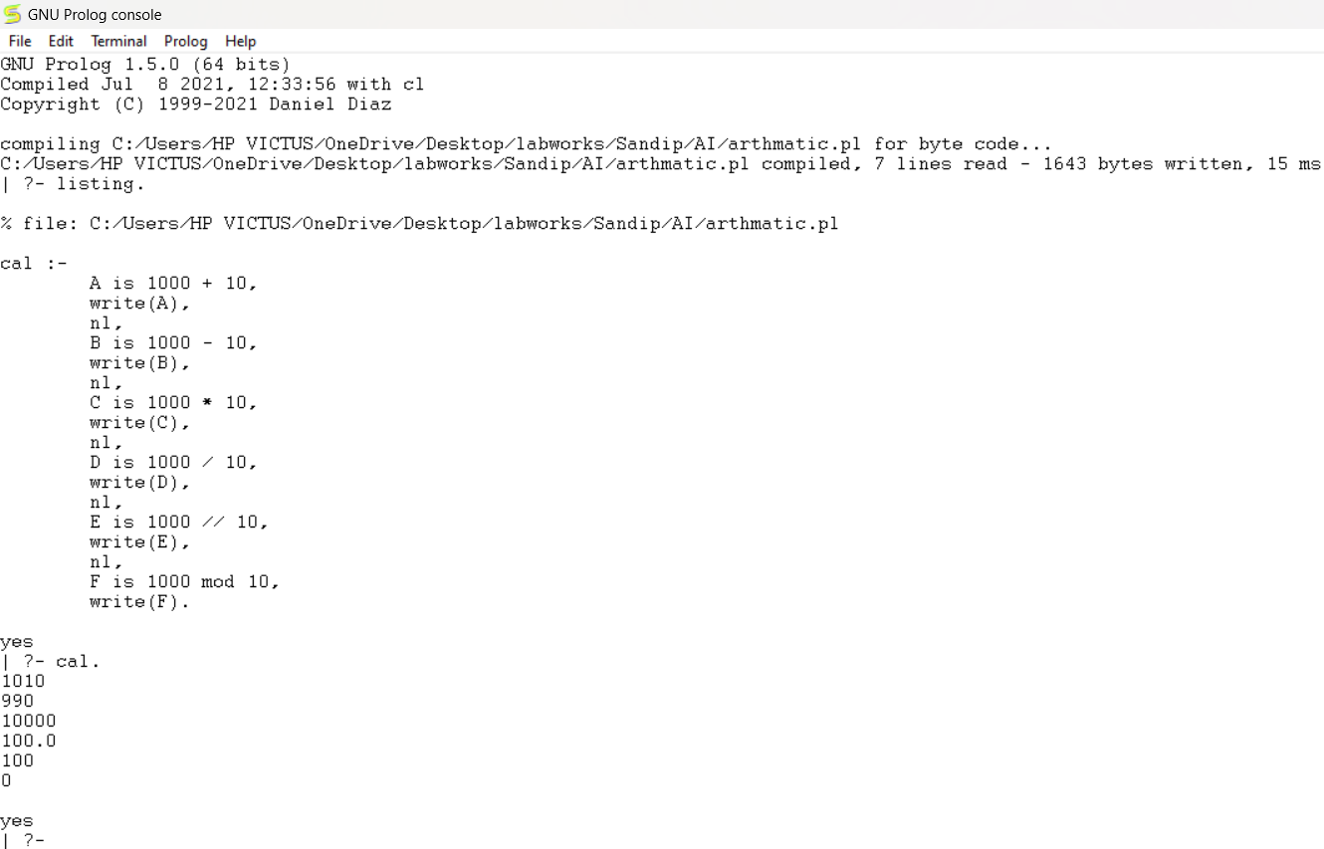

**Q.2. Write a prolog program to show comparison operators:**

|  |  |
| --- | --- |
| **Operator** | **Meaning** |
| **>** | **greater than** |
| **<** | **less than** |
| **>=** | **greater than or equal to** |
| **=<** | **less than or equal to** |
| **=:=** | **values are equal** |
| **=\=** | **values are not equal** |

**Objectives:**

The objective of this Prolog program is to demonstrate the use of basic comparison operators in Prolog. The program aims to provide clear examples of how to compare values using operators such as greater than, less than, greater than or equal to, less than or equal to, equal to, and not equal to. Through a series of queries, users will learn how to perform comparisons and make decisions based on these comparisons in Prolog. Additionally, the program seeks to illustrate the syntax and functionality of each comparison operator within the Prolog environment. Ultimately, this program serves as a comprehensive guide for understanding and utilizing comparison operations in Prolog.

**Code:**

gt(X,Y):- X>Y,write('X IS GREATER THAN Y').

gtt(X,Y):- X<Y,write('X IS LESS THAN Y').

gttt(X,Y):- X>=Y,write('X IS GREATER OR EQUAL TO Y').

gtttt(X,Y):- X=<Y,write('X IS LESS OR EQUAL TO Y').

gttttt(X,Y):- X=:=Y,write('X IS EQUAL TO Y').

gtttttt(X,Y):- X=\=Y,write('X IS NOT EQUAL TO Y').

**Output:**

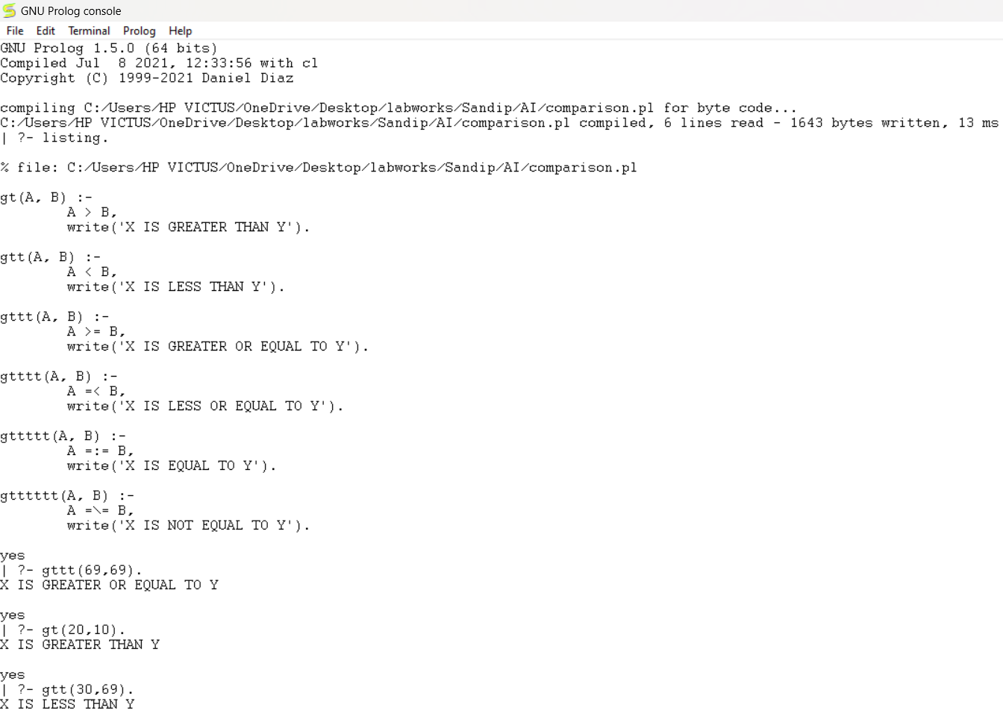

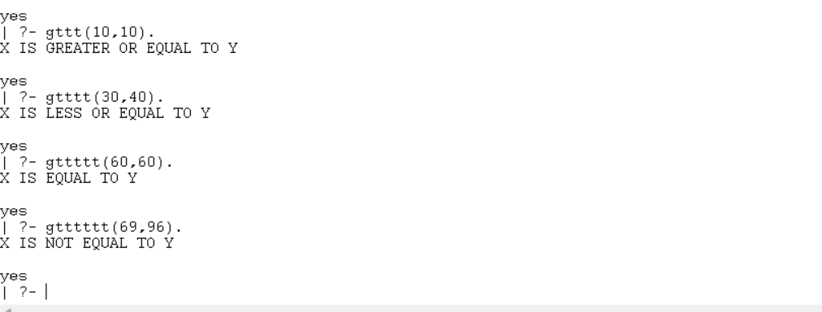

**Conclusion:**

The Prolog programs provided effectively demonstrate the use of both arithmetic and comparison operators within the Prolog environment. Through clear and practical examples, users can understand how to perform various arithmetic operations such as addition, subtraction, multiplication, and division, as well as how to apply comparison operators to evaluate relationships between values. These programs serve as comprehensive guides, illustrating the syntax and functionality of each operator in Prolog. Ultimately, they equip users with the necessary knowledge to perform arithmetic calculations and make logical comparisons in Prolog programming.